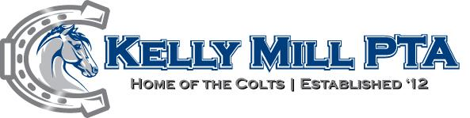
Teacher /Staff Favorites
Name: Chelsea Daher
- Color(s): black, pink, red
- Top 3 Restaurants: Chick fl a, Panera, and Brooklyn’s Bagels
- Snack: Gardettos, white cheddar cheese itz and cool ranch Doritos
- Starbucks Drink: caramel macchiato with an extra shot of espresso
- Flower: peony
- Reading Material: baking and cooking books/magazines
- Holiday / Time of Year: Christmas and summer
- Gift Ideas for Under $20: Candles, fragrant hand soaps, gift cards
- Activity/Hobby: Home decorating, walking and board games
- Movies: comedies
- Store to Shop at: Kirkland’s, Target, and hobby lobby
- I collect: candles and holiday pillows
- Where did you attend college? Georgia Southern University
- What do you do for fun? I love to bake and cook
- If you could spend one day pampering yourself, what would you do? I would go get a manicure and pedicure
- Is there anything that you do not like? (Now is your chance)
- Is there anything that you are allergic to or cannot have? I do not have any allergies
- Please tell us anything else you would like us to know about you.
- Classroom Office Wish List: Clorox wipes and dry erase markers
Thank you for filling out this form. We appreciate you and your commitment to our children.

